Description | VSFTPD 2.3.4 contains a backdoor that allows an attacker to gain unauthorized access and execute commands on the server.
Vulnerabilty-Name | VSFTPD 2.3.4 Backdoor Vulnerability
Service/Version | FTP/vsftpd 2.3.4
Port | 21
Severity | Critical
CVE | CVE-2011-2523
POC | Step 1: Scan the FTP port using nmap -sV -p 21 192.168.0.105  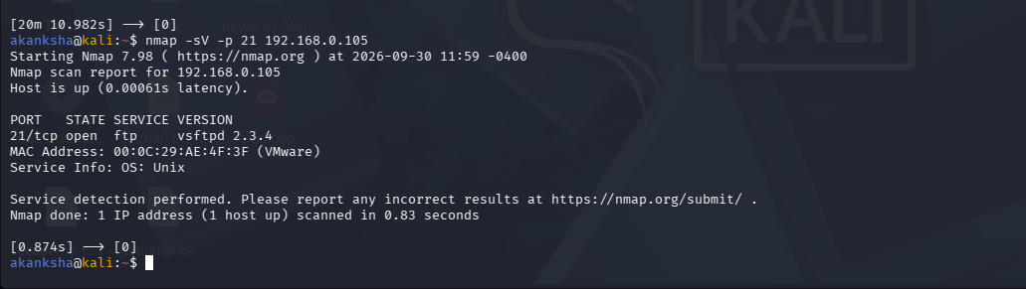  - Confirm vsftpd 2.3.4 is running.  Step 2: Open Metasploit by using msfconsole and search VSFTPD 2.3.4  - use vsftp 2.3.4  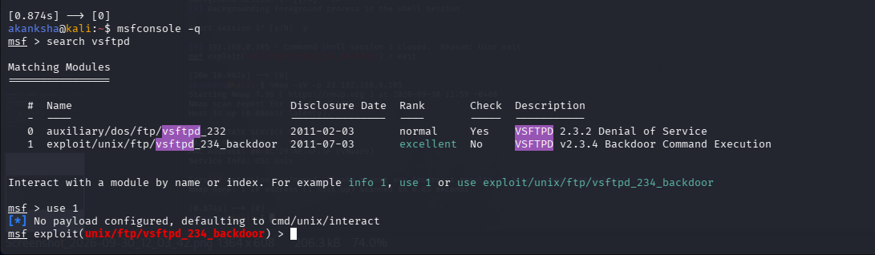  - Set the target IP using set HOSTS Command  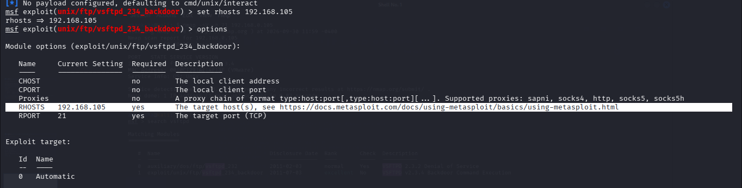  - Run the exploit and verify access using whoami  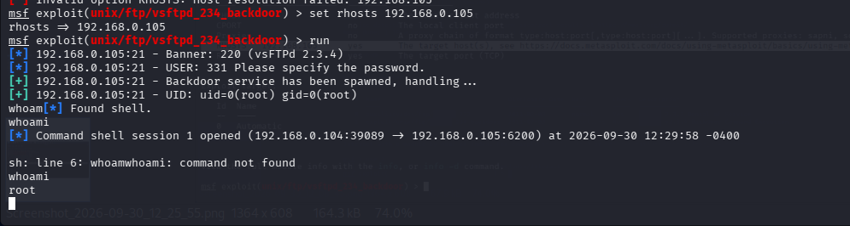  - Unauthorized command access was obtained on the target system.
CVSS Score | 10.0 Critical
Impact | An attacker can gain unauthorized access and execute commands on the server.
Remediation | - Upgrade vsftpd to a secure version.  - Remove the vulnerable vsftpd 2.3.4 version.  - Disable FTP if it is not required.  - Use SFTP instead of FTP where possible.

Description | The SSH service is running an old version of OpenSSH that may contain known security vulnerabilities.
Vulnerabilty-Name | OpenSSH 4.7p1 Vulnerabilities
Service/Version | SSH/OpenSSH 4.7p1 Debian 8ubuntu1
Port | 22
Severity | Critical
CVE | CVE-2008-0166
POC | Step 1: SSH service was identified using nmap  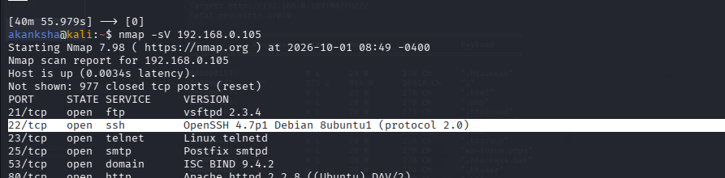  - Confirm OpenSSH 4.7p1 is running.  Step 2: Check the version for known vulnerabilities using msfconsole  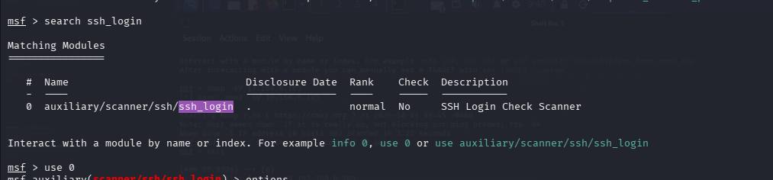  Step 3: Select the SSH Login Module in Metasploit, select the auxiliary SSH login module  - Bu use 0 command  Step 4: set RHOSTS, Pass_File, User_File for bruetforce  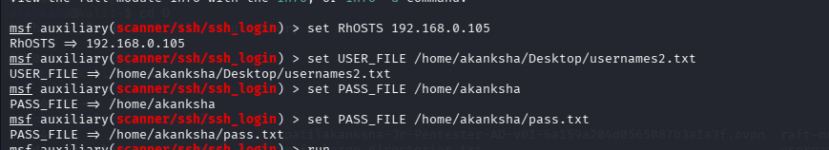  - Then exploit the module using run command or exploit command  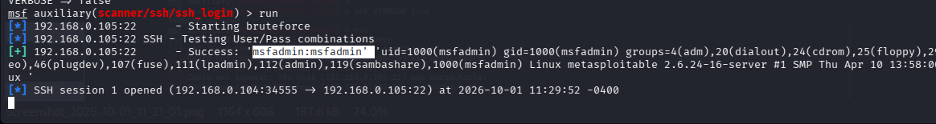  - Successfully identified the valid username and password.  Step 5: View the active session  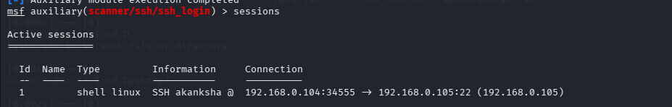  Step 6: use command session -i 1 to access the active session.  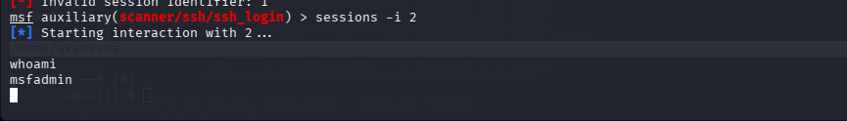  - Verify the access using whoami Command  - Successful SSH authentication provided access to the target system, as shown in the screenshot
CVSS Score | 9.8 (Critical)
Impact | - Unauthorized SSH access to the system.  - Access to sensitive files and information.  - Ability to execute commands on the server.  - Possible further compromise of the system.
Remediation | - Use strong and unique SSH passwords.  - Disable default or unused accounts.  - Limit SSH access to trusted IP addresses.  - Enable key-based authentication instead of passwords.  - Keep the SSH service updated with security patches.

Description | Telnet sends usernames, passwords, and data in plain text, which can be captured by an attacker.
Vulnerabilty-Name | Telnet Cleartext Communication
Service/Version | Telnet/Linux telnetd
Port | 23
Severity | Critical
CVE | N/A
POC | Step 1: Scan port 23 using nmap  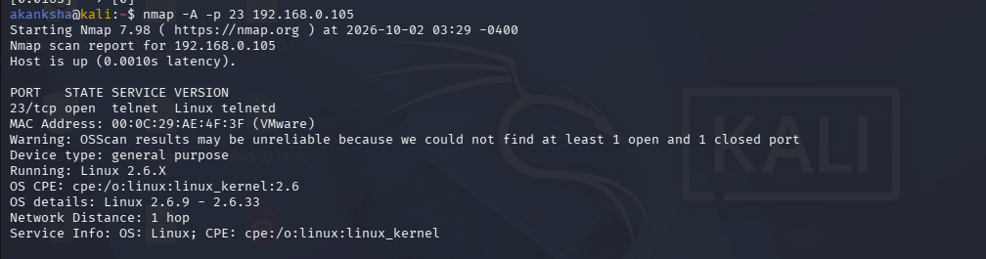  - Confirm that Telnet is running on port 23.  Step 2: Brute-Force Telnet Credentials Using Hydra  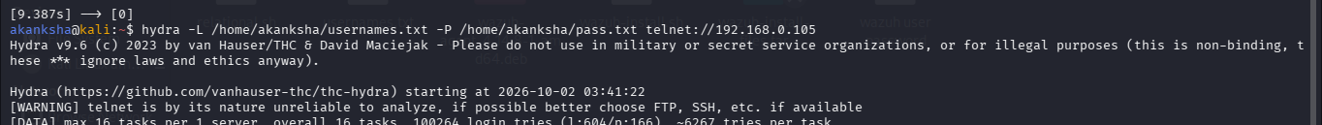  Step 3: Successfully brute-forced the username and password and identified valid Telnet credentials.  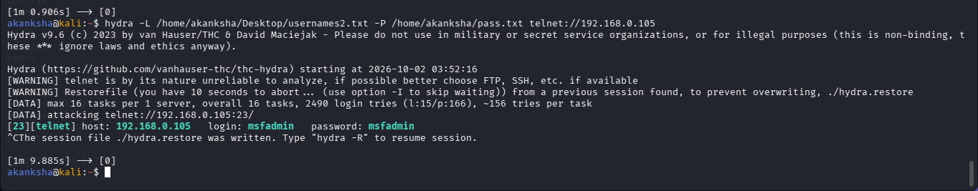  Step 4: Try to login Using the Discovered Credentials.  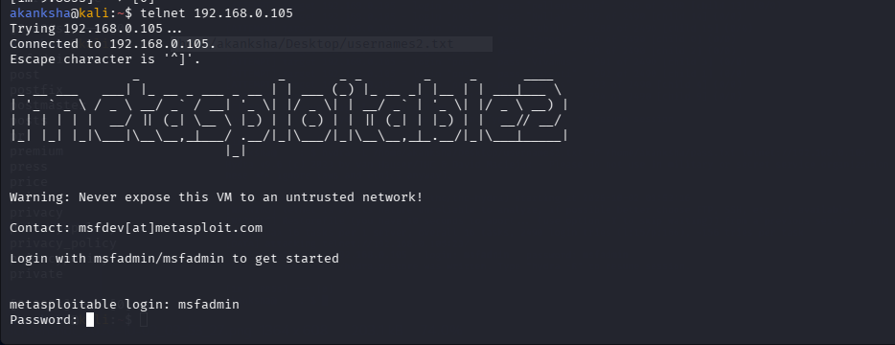  - Successfully logged in to Telnet using the above credentials.  Step 5: Verified successful access to the target system through Telnet.  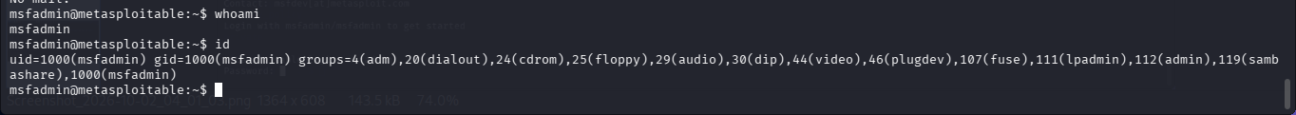  - Successfully logged in to the Telnet service using the discovered credentials.
CVSS Score | 9.8 Critical
Impact | Credentials can be captured in plain text.  Sensitive information can be exposed.  Attackers may gain unauthorized access.  The connection can be intercepted by a network attacker.
Remediation | Disable Telnet if it is not required.  Use SSH instead of Telnet.  Avoid sending credentials over unencrypted connections.  Restrict remote access using firewall rules.  Use secure and updated services.

Description | The SMTP server supports the outdated SSLv2 protocol, which has known security weaknesses.
Vulnerabilty-Name | SSLv2 Supported
Service/Version | SMTP/postfix smtpd
Port | 25
Severity | Medium
CVE | N/A – SSLv2 Enabled
POC | Step 1: Nmap confirmed that SSLv2 is enabled and listed supported SSLv2 ciphers.  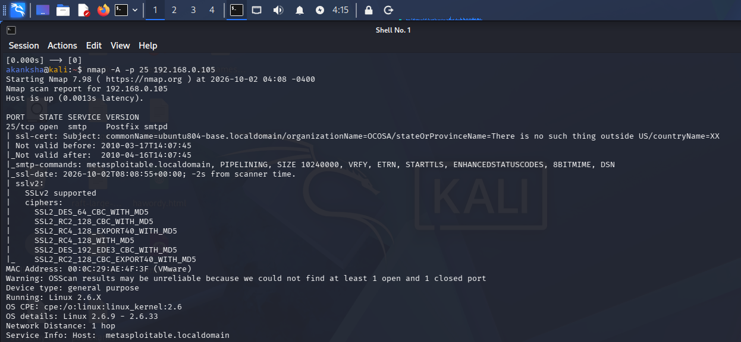  - Confirm Postfix smtpd is running on port 25.  - Verify that SSLv2 is supported by the SMTP service.  Step 2: Check the SMTP Service Using Metasploit  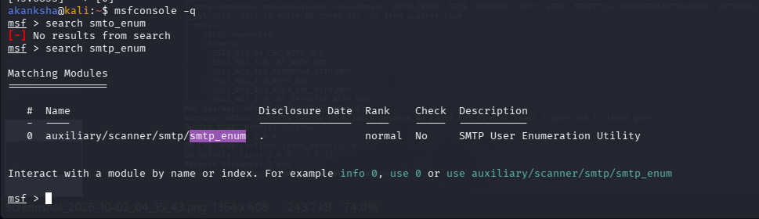  - Searched for smtp_enum in Metasploit.  - The auxiliary/scanner/smtp/smtp_enum module was used.  Step 3: Selected the SMTP User Enumeration module.  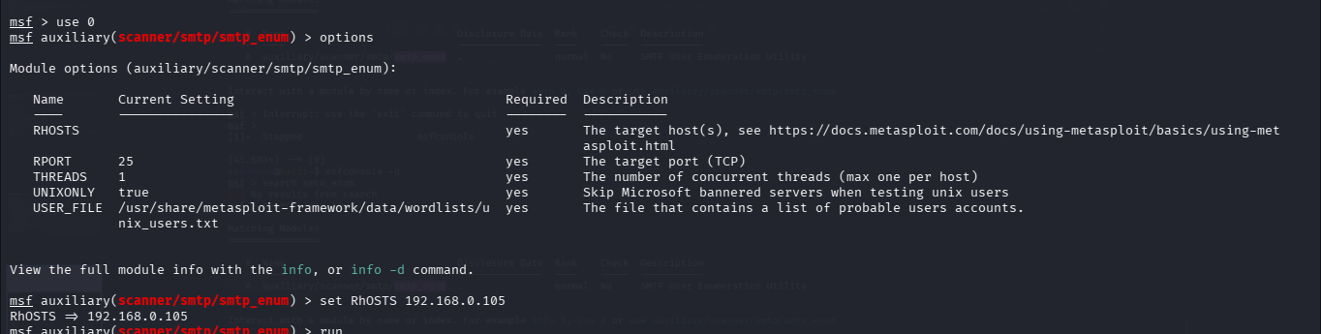  - Set the target IP and run the module.  Step 4: start the netcat service to another tab  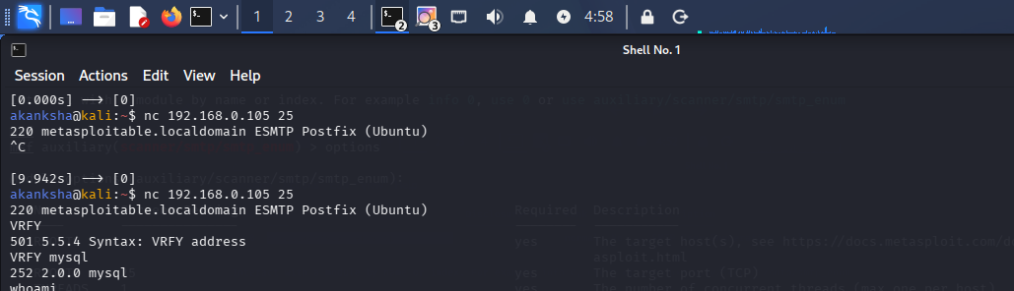  - The SMTP service was successfully connected and responded with the Postfix (Ubuntu) banner.  - The scan successfully enumerated valid SMTP usernames, including backup, bin, daemon, ftp, games, mail, mysql, nobody, postfix, root, sshd, and others.
CVSS Score | 5.3 (Medium)
Impact | Attackers can discover valid usernames.  Username information can help with password attacks.  It can make targeted attacks easier.  It may expose information about system account
Remediation | Disable the SMTP VRFY command.  Disable unnecessary SMTP user enumeration.  Configure Postfix to reject VRFY requests.  Use strong passwords and account protection.  Keep the mail server properly configured and updated.

Description | WebDAV is enabled on the /dav/ directory, allowing unauthorized users to access and potentially modify files on the web server.
Vulnerabilty-Name | WebDAV Enabled / Unauthorized WebDAV Access
Service/Version | HTTP / Apache 2.2.8 (Ubuntu) with WebDAV enabled
Port | 80
Severity | Medium
CVE | N/A — WebDAV Enabled / Unauthorized WebDAV Access
POC | Step 1: Scanned port 80 using Nmap and identified Apache HTTP Server 2.2.8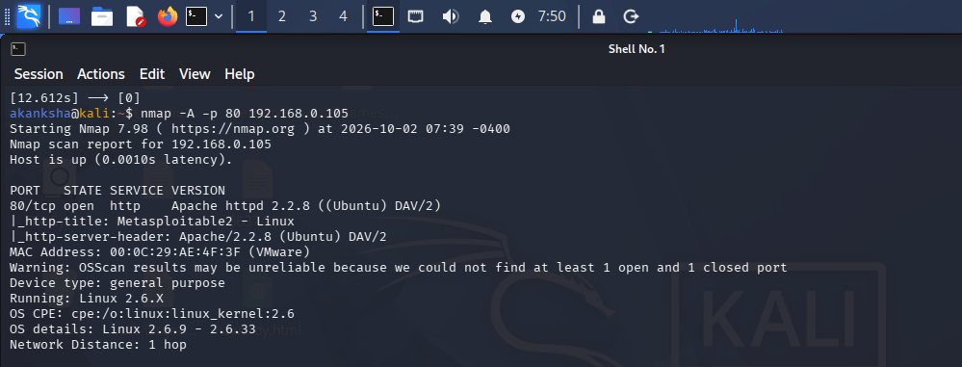  Step 2: Used Dirb to enumerate hidden directories and files on the web server.  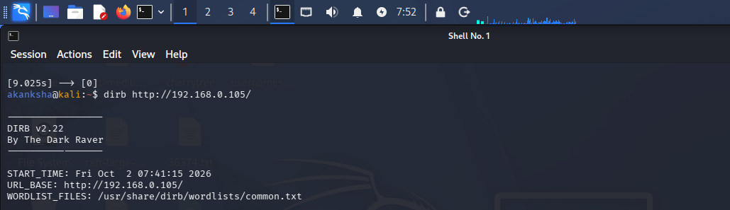  Step 3: Found the /dav/ directory using Dirb, indicating that WebDAV is enabled on the server.  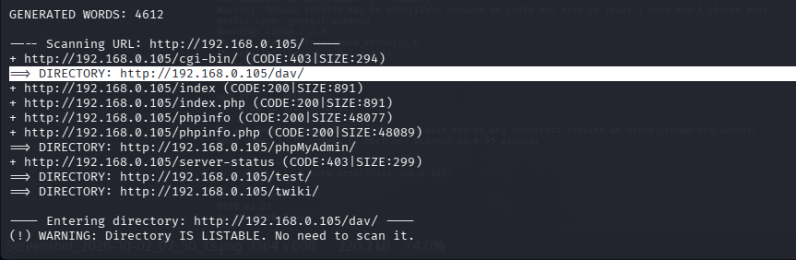  Step 4: Connected to the /dav/ directory using Cadaver and accessed the WebDAV service successfully.  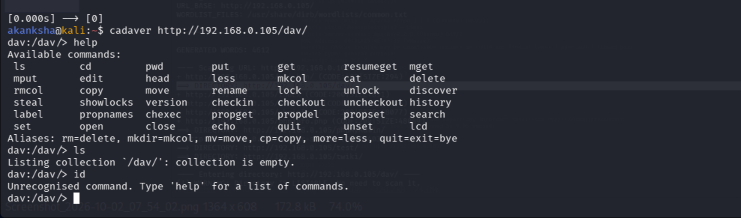
CVSS Score | 6.5 (Medium)
Impact | Attackers may access files through WebDAV.  Unauthorized users may modify or upload files.  Malicious files could be placed on the web server.  The website could be compromised if uploaded files are executed.
Remediation | Disable WebDAV if it is not required.  Restrict /dav/ access to authorized users.  Enable proper authentication and permissions.  Prevent execution of uploaded files.  Keep Apache updated.

Description | The vulnerable Samba service allows an attacker to execute commands remotely on the target system.
Vulnerabilty-Name | Samba usermap_script Remote Code Execution
Service/Version | netbios-ssn Samba smbd 3.0.20-Debian
Port | 445/139
Severity | Critical
CVE | CVE-2007-2447 — Samba username map script Command Injection.
POC | Step 1: Scanned port 445 using Nmap to identify the SMB service and version.  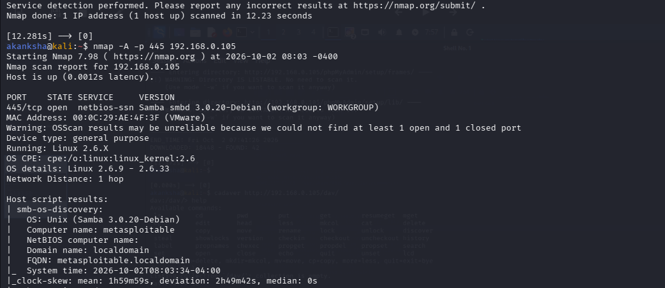  Step 2: Started Metasploit and selected the Samba usermap_script exploit module.  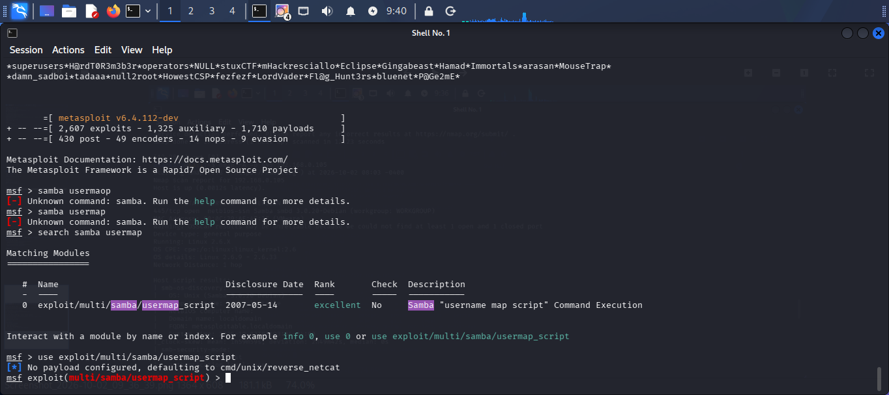  Step 3: Set the target IP address for the Samba usermap_script exploit.  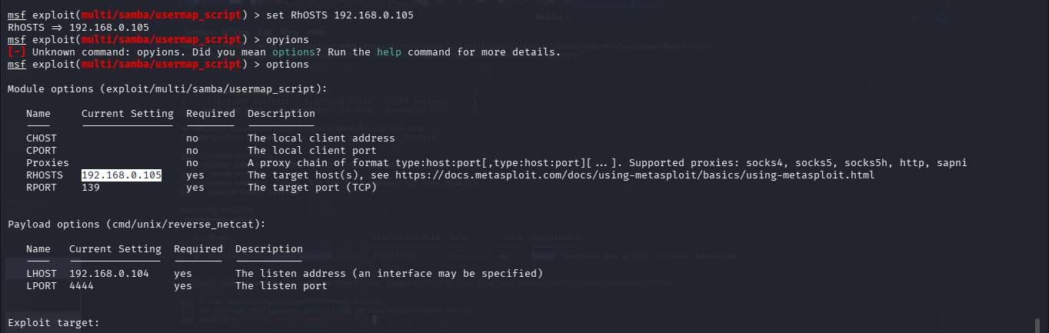  Step 4: Executed the Samba usermap_script exploit against the target system.  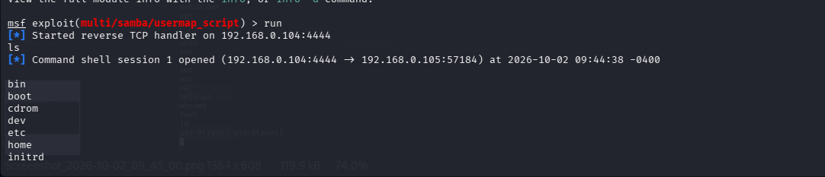  Step 5: Verified the obtained session and confirmed access to the target system.  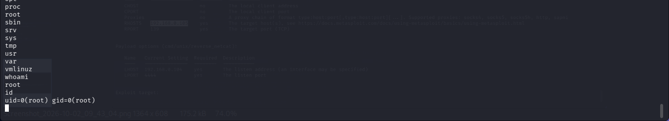
CVSS Score | 10.0 (Critical)
Impact | Remote command execution on the target.  Unauthorized access to the system.  Sensitive files and data may be accessed.  The system may be fully compromised.
Remediation | Upgrade Samba to a patched version.  Disable the vulnerable username map script configuration.  Restrict SMB access using firewall rules.  Disable SMB if it is not required.  Keep Samba and the operating system updated.

Description | RSH/Rlogin sends data without encryption and can allow unauthorized remote access.
Vulnerabilty-Name | Insecure RSH/Rlogin Service
Service/Version | netkit-rsh rexecd
Port | 512/TCP
Severity | High
CVE | N/A – Insecure/unencrypted service configuration
POC | Step 1: Scanned port 512 using Nmap and identified the netkit-rsh rexecd service.  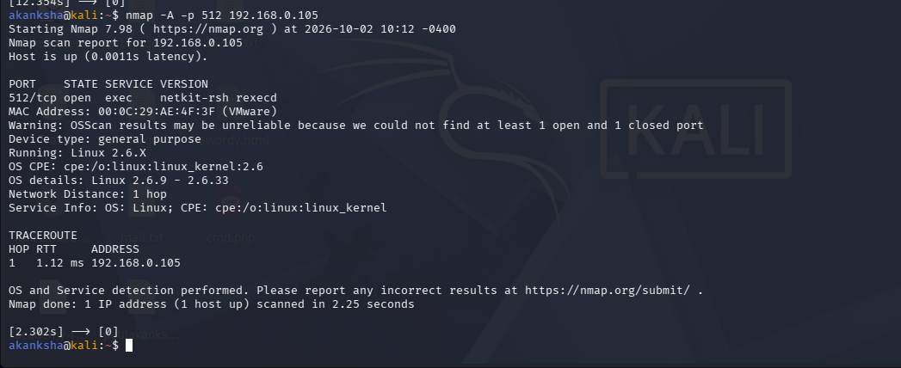  Step 2: Used the Rlogin client to connect to the target as the root user.  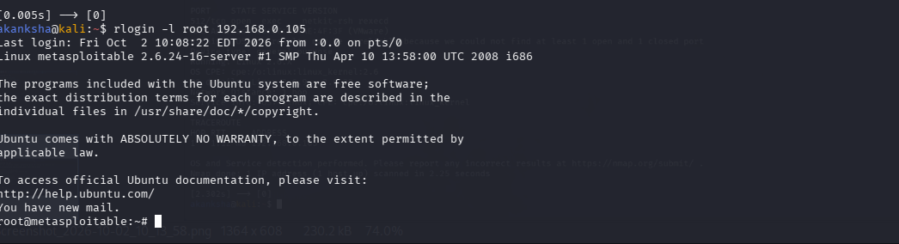  Step 3: Verified the Rlogin session and confirmed the user access on the target system.  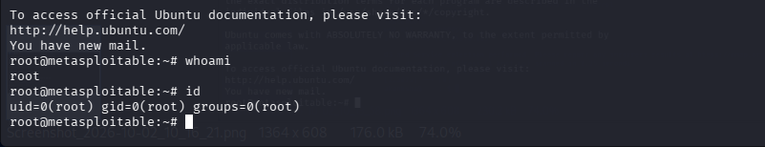
CVSS Score | 7.5 (High)
Impact | • Credentials and data can be exposed in plain text.  • Attackers may gain unauthorized remote access.  • Commands can be executed on the target system.  • Sensitive files and information may be accessed.
Remediation | • Disable RSH/Rlogin if not required.  • Use SSH instead of RSH/Rlogin.  • Restrict access to trusted hosts only.  • Use firewall rules to block unauthorized access.  • Remove or disable unnecessary legacy services.

Description | Java RMI can allow remote access and may be vulnerable to unauthorized code execution if improperly configured.
Vulnerabilty-Name | Java RMI Remote Code Execution
Service/Version | GNU Classpath grmiregistry
Port | 1099/TCP
Severity | High
CVE | N/A
POC | Step 1: Scanned port 1099 using Nmap and identified the Java RMI registry service.  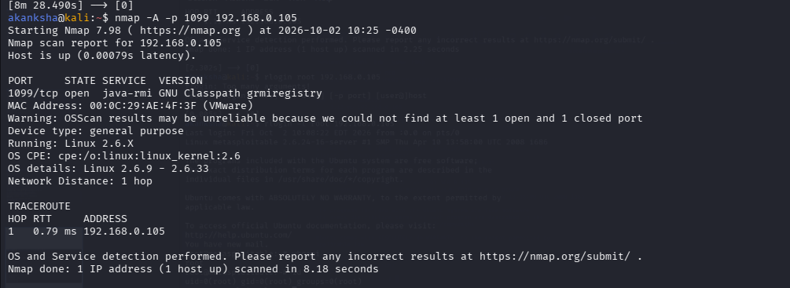  Step 2: Started Metasploit, searched for the Java RMI module, and selected the appropriate exploit module.  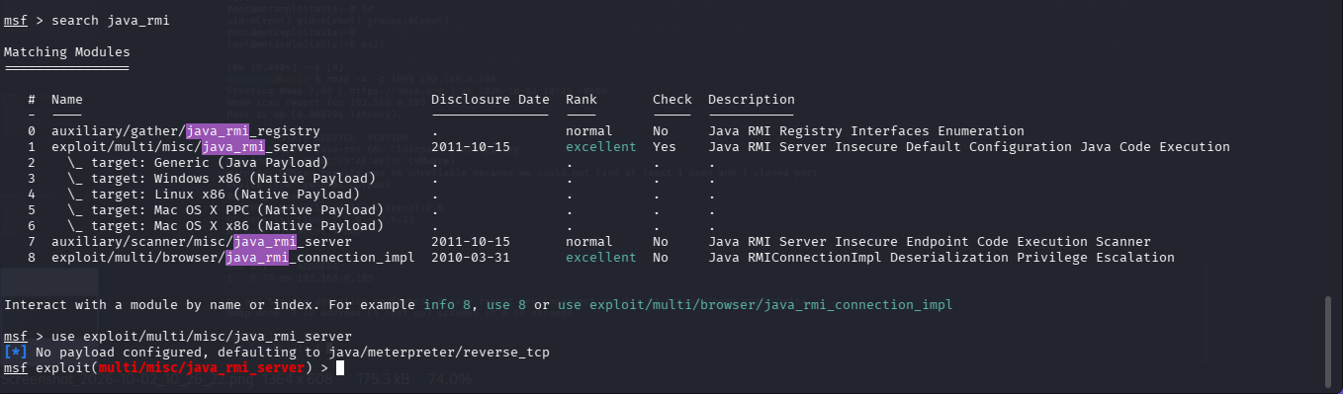  Step 3: Set the target IP address and ran the Java RMI exploit against the target.  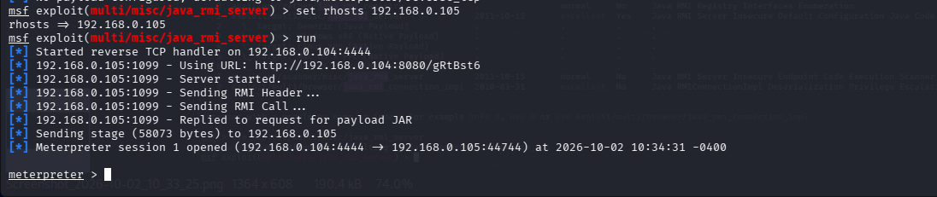  - The Java RMI exploit successfully opened a Meterpreter session on the target system.  Step 4: Used the shell command from the Meterpreter session to open a system shell.  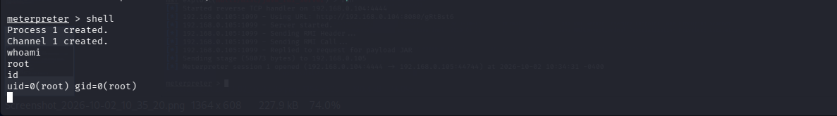  - Verified root access using whoami and id.
CVSS Score | 10.0 (Critical)
Impact | • Remote code execution on the target system.  • Attacker can obtain a Meterpreter session.  • Root-level access can be obtained.  • Complete system compromise is possible.
Remediation | • Disable Java RMI if it is not required.  • Restrict RMI access to trusted hosts.  • Upgrade Java/RMI to a supported and patched version.  • Use firewall rules to block unauthorized access to port 1099.  • Avoid exposing RMI services directly to untrusted networks.

